ANNEX 1
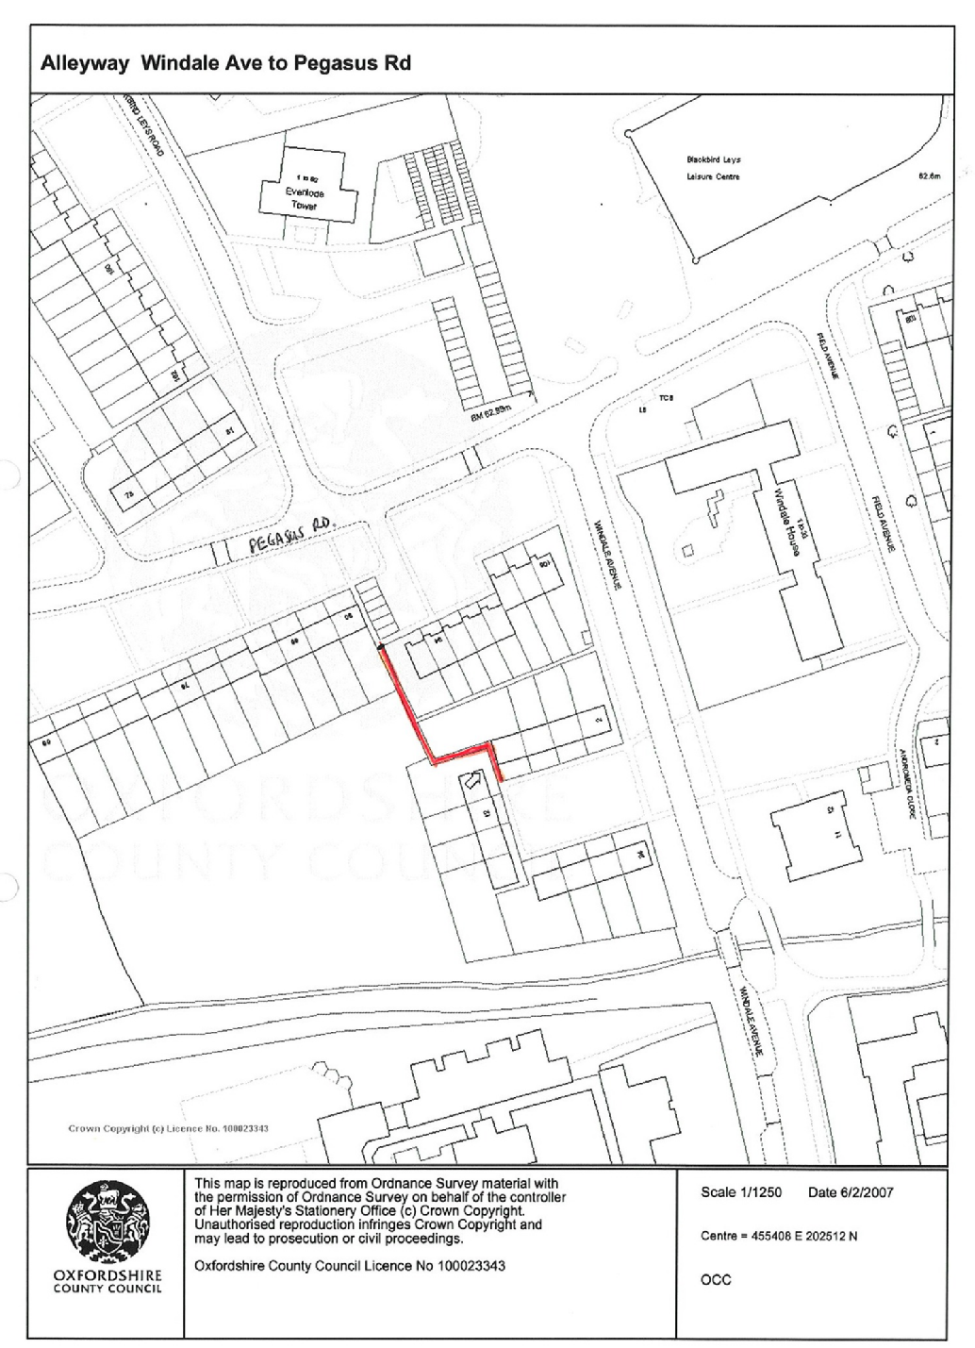
ANNEX 2

Gating Order Protocol and Assessment
Windale Avenue, Oxford

Background

Section 17 of the 1998 Crime and Disorder Act requires the Council to consider crime and disorder reduction and community safety in the exercise of all their duties and activities.

Section 2 of the Clean Neighbourhoods and Environment Act 2005 permits councils to make, vary or revoke gating orders in respect of highways within their area. This enables councils to restrict public access to any public highway up to and including unclassified roads by gating it (at certain times of day if applicable), without removing its underlying highway status, on grounds of anti-social behaviour as well as crime.

In order to achieve consistency of approach in considering requests for gating orders this protocol sets out the main assessment criteria and offers guidance in their application.

Assessment Criteria.

- There must be clear evidence that premises adjoining or adjacent to the highway are affected by crime or anti-social behaviour. It is insufficient to rely solely on the views of the local community and documented records such as police incident reports should be sought.

- There must be clear evidence that the existence of the highway is facilitating the persistent commission of criminal offences or anti-social behaviour. Documentary evidence is required as 1 above. This may be more difficult to obtain in a rural environment but it is inappropriate to rely on hearsay.

- A gating order may not be made if it would restrict the public right of way over a highway which is the only or principal means of access to any dwelling.

- If the highway is the only or principal means of access to business or recreational premises a gating order should not restrict public rights of way while those premises are normally in use. A limited period order may suffice in these circumstances.

- If the highway constitutes a through route, unless there are very exceptional circumstances, there must be a reasonably convenient alternative which is suitable for all users including the disabled. The alternative should be no less “commodious” than the highway to be gated and should not be likely to lead to an increase in vehicular use. An alternative can be more “commodious” even if it is longer but is more suitable in other respects.
- If the reported incidents of crime or anti-social behaviour occur at specific times or on specific days consideration should be given to limiting the periods to which an order applies. The benefits of permitting public use of the highway at certain times will need to be weighed against the practicalities of effecting periodic closure. Management arrangements for periodic closure will need to be made clear in the application.

- An order may exclude specific persons or groups of people from the effects of the restriction and consideration should be given to the need for such exemptions. The benefits of making specific exemptions should be weighed against the ability to both manage and enforce the restrictions. In any case there must be an exemption for occupiers of premises adjacent to or adjoining the highway to be gated.

- The likely effectiveness of the order in reducing crime and anti-social behaviour should be weighed against the likely effects of making the order on:
- the occupiers of premises adjoining or adjacent to the highway
- other persons in the locality
- the emergency services
- statutory undertakers
When considering the effects on others, the potential for a gating order merely transferring a problem elsewhere in the vicinity should be assessed.

- Alternative means of preventing crime and anti-social behaviour should be considered and weighed against the option of introducing a gating order before it is decided to proceed. The Community Safety Team and the Police should be consulted on the possibility of using other means to deal with the root cause of the problem.

- Gating Orders should not be considered to be permanent and should be reviewed on an annual basis when the need for the order and the effectiveness of it should be reconsidered. At this time an order can be varied or revoked as appropriate.

Gating Order Assessment for Windale Ave, Blackbird Leys, Oxford

1. | Is there clear evidence that premises adjoining or adjacent to the highway are affected by crime or anti-social behaviour? | Yes, three out of four residents have evidence of crime or anti-social behaviour. In addition, the local beat officer has first hand experience of this alleyway.
2. | Is there clear evidence that the existence of the highway is facilitating the persistent commission of criminal offences or anti-social behaviour? | Yes, as 1. The alignment of the alleyway provides for ‘blind spots’ which cannot be seen from either end.
3. | Would a gating order restrict the public right of way over a highway which is the only or principal means of access to any dwelling? | No. The four residents would be supplied with keys to allow access to the rear of their properties.
4. | Is the highway the only or principal means of access to business or recreational premises? If so would a limited period order be applicable? | No.
5. | If the highway constitutes a through route is there a reasonably convenient alternative which is suitable for all users, including the disabled?  Would the alternative be likely to lead to an increase in vehicular use? | The alternative route follows the road from Pegasus Road to Windale Avenue. The footway is in good condition with only a slight gradient. There would be an extra distance of 10 metres.  No increase in vehicular use is envisaged.
6. | Do the reported incidents of crime or anti-social behaviour occur at specific times or on specific days?  If so, would limiting the periods to which the order applies be appropriate and could it be managed? | Anecdotal evidence suggests that most incidents occur after dusk. As there is no essential use of the alleyway a permanent closure would be simple to operate and is therefore proposed.
7. | Should the order exclude specific persons or groups of people from the effects of the restriction? | Yes. The adjacent residents and statutory bodies.

8. | How will the order affect:  - Occupiers of premises adjoining or adjacent to the highway  - Other persons in the locality  - The emergency services  - Statutory undertakers | The making of the Gating Order is not likely to impact on emergency services or statutory undertakers and any inconvenience to highway users, other persons in the locality and occupiers would be negligible.
9. | Have alternative means of preventing crime and anti-social behaviour been considered and weighed against the option of a gating order? If so why is a gating order preferable? | PC Wills’ report suggests that a gating order would be beneficial. Police action is not able to achieve an improvement in this location.
10. | Will the gating order result in a relocation of the problem? If so what measures are needed to address this? | There is no obvious location in the vicinity where the problems could recur. TVP are addressing similar issues across the estate.

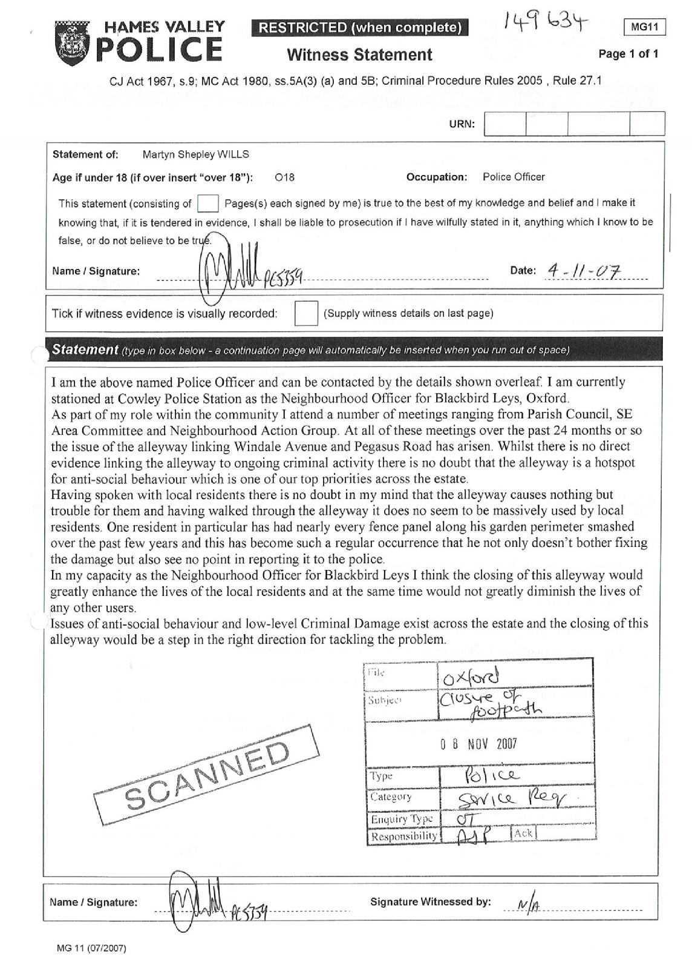

The statutory definition of anti-social behaviour is behaviour by a person which causes or is likely to cause harassment or alarm to one or more persons not of the same household as himself.

